|  |  |
| --- | --- |
| More evidence of the "fireproofing effect" of insect outbreaks in a forest  - Wildfire Today  Western Spruce Budworm in North America  *Choristoneura occidentalis* | Abstract  The western spruce budworm is a major defoliator of North American forests. Climate change may increase the frequency and severity of WSB outbreaks, although the mechanisms are not well-understood. This living document explores the background information available on this species and their impacts.  OLIVIA SANTIAGO  MS Thesis |

# Evolutionary History

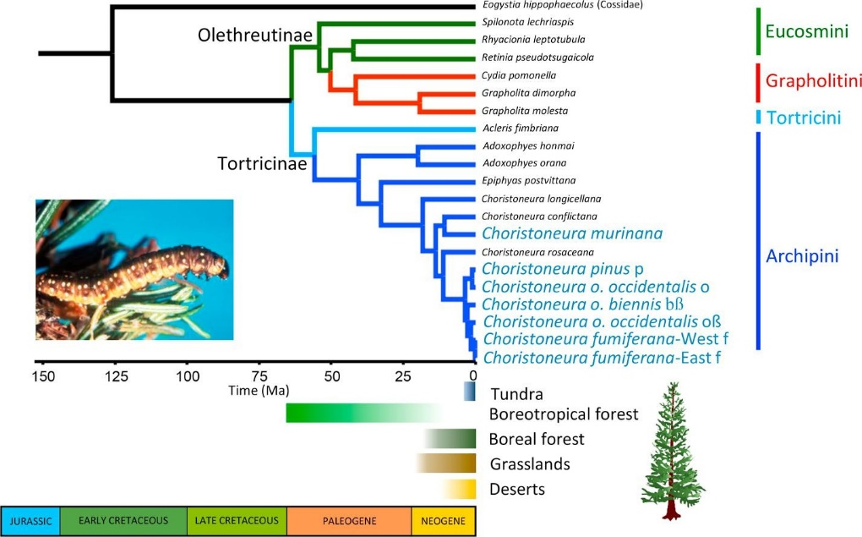

Figure . Evolutionary history of the genus Choristoneura. The phylogeny is matched with the changes in biome in North America over geologic time. The figure suggests that the genus evolved with the emergence of boreal forests. (Fagua et al 2018)

The ancestors of the western spruce budworm and the *Choristoneura* genus evolved from generalist herbivores about 11 million years ago, although today the group contains many specialized conifer pests. Evidence suggests the convergent evolution of conifer-specialists in this genus is a result of the emergence of boreal forests in the Northern Hemisphere during the late Miocene (Fagua et al 2018).

# Life Cycle of the Western Spruce Budworm

Figure . A diagram of the life cycle of the eastern spruce budworm. The eggs must pupate six times to reach maturity over the course of one year, from fall to summer. (Rauchfuss & Ziegler 2011)

# Introduction

Western spruce budworm outbreaks may increase in frequency and severity with the onset of climate change, although the drivers that control the population dynamics of this species are not fully understood yet. This report presents introductory information that will lay the foundation to understand how the climate at the intraannual, interannual, and multidecadal scales influence WSB outbreaks; as well as how stand structure, composition, and drought stress affect stand recovery from WSB outbreaks in the Southern Colorado Rocky Mountain Ecoregion. We will use dendrochronological methods and remote sensing techniques to elucidate the drivers of regionally synchronous WSB outbreaks across complex landscapes. We hypothesize that the driver may be (a) above average summer moisture (Price 1991) that increases foraging availability, (b) drought (White 1984, Mattson and Haack 1987) that increases foraging quality, or (c) above average moisture following drought (Flower et al. 2014, Flower 2016, Ellis and Flower 2017).

# Western Spruce Budworm

The western spruce budworm (*Choristoneura occidentalis)* is a member of the genus *Choristoneura*. Species within this group are conifer-feeding budworms that evolved and diversified when boreal forests formed and expanded in North America during the late Miocene (Fagua et al 2018). Today, this 4-million-year-old adaptation has made the genus into notorious, economically damaging insects of coniferous forests in the United States and Canada because it is such an effective defoliator. The western spruce budwormis a univoltine species. The eggs hatch in the late summer and first instars migrate to overwintering sites. The larvae molt to the second instar and take shelter in silken cocoons under bark scales. They emerge in spring, from April to June, and mine buds and old needles until bud flush. Once bud flush arrives, the larvae web new needles together to feed in a protective shelter through the sixth instar. They pupate in these shelters and emerge in August as adults. Then they lay up to 130-150 eggs on the underside of a needle and complete their life cycle (Pederson et al 2011). It is crucial that the budworm emerge at the proper time to have access to the nutritious bud flush of its host. Emerging too far in advance of bud flush results in considerable mortality during the foraging period, while emerging after bud flush results in higher mortality and lower fecundity (Régnière & Nealis 2018). As climate change advances the phenology of trees there could be a phenological mismatch between WSBand its preferred hosts, leading to novel interactions. Black spruce does not experience severe defoliation from spruce budworm currently because of its delayed bud flush, however, evidence suggests if it advances its phenology, it may better support budworm survival and suffer increased defoliation (Fuentealba et al 2017).

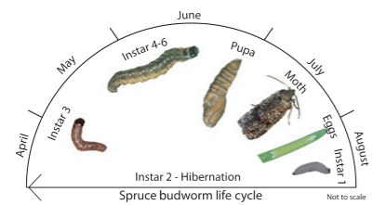

Figure 1. The Lifecycle of the Western Spruce Budworm. In one year, their lifecycle is complete. The adults lay their eggs in the late summer, who emerge, find a place to shelter over winter, and emerge in spring to feed on conifer needles and mature into adults and complete their lifecycle ( from Rauchfuss & Ziegler 2011).

# The Hosts of Western Spruce Budworm

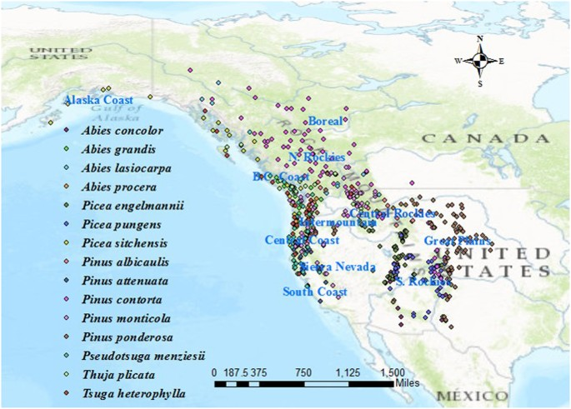

Figure 2. The distribution of conifer species in North America. Host genera include the true-firs (Abies), spruce (Picea) and Douglas-fir (Pseudotsuga menziesii). (Liu & El-Kabsasy 2018)

Western spruce budwormpreferentially feeds on Douglas-fir, true firs (*Abies* spp.), and to a lesser degree, spruce (*Picea* spp.), calling into questions why it is called a “spruce” budworm in the first place. The phenological and physiological response of defoliated hosts have been studied include delaying bud flush (Chen et al 2001) in Douglas-fir and advancing bud flush in balsam-fir, black spruce, and white spruce (Deslauriers et al 2018) under laboratory conditions. It should be noted Deslauriers attributed this response not as a defense against defoliation, but as a response to maximize primary growth.

# Ecological Effects of Western Spruce Budworm Defoliation

Defoliators play a major role in forest ecosystems with important consequences for the provisioninong of ecosystem services. Western spruce budworm is an endemic defoliator of conifers in North America that typically exists at low levels, with populations managed by predation (Flower et al 2014). Defoliation may impact nutrient cycling (Arango et al 2019) by changing the throughfall N and P concentrations in areas of high defoliation, resulting in much higher phosphorus concentrations in the soil and the immobilization of nitrogen. Additionally, outbreaks can disrupt carbon sequestration (Kurz et al 2008), habitat provisioning (Kelly et al 2019), and timber supply (MacLean et al 2016).

# Reconstructions of Past Western Spruce Budworm Outbreaks

The mechanisms that drive western spruce budworm outbreaks are not well understood currently. Dendrochronological methods are often employed to elucidate the main drivers of outbreaks in combination with paleoclimatic data and statistics. Reconstructions in the Pacific Northwest revealed that WSB outbreaks tended to occur at the end of droughts (Ellis & Flower 2017, Flower et al 2014), had spatiotemporal patterns at regional scales (Meigs et al 2015), and did not have a relationship to fire years (Harvey et al 2018). The reconstructions of the Rocky Mountains showed a similar pattern, revealing a regionally synchronous pattern of outbreaks that occurred during a period of increased moisture after a drought (Ryerson et al 2003, Flower 2016). The reconstructions of British Columbia showed strong synchrony for some, but not all outbreak events (Axelson et al 2015), a consistent number of outbreaks since the 1800s (Alfero et al 2014), and evidence that hosts may be increasingly susceptible to successive defoliation events since the 2000s (Maclauchlan et al 2018). One study looked at WSB outbreaks as a whole for western North America and found that this regional synchrony extends to the whole of the continent and appears to be a natural part of the population dynamics of WSB (Flower 2016), although synchronous outbreaks have occurred more frequently during the 20th century.

Mitigating the effects of these outbreaks is a management concern as these defoliators are a major threat to the economy of these areas. Multistoried stands with high host densities and varied stem sizes are the most severely disturbed by insect agents (Hadley & Veblen 1993). These stands and are interpreted by managers as “high hazard” sites (Pederson et al 2011) that must be directly altered by thinning, prescribed fire, or chemical and biological pesticides. The goal is to create a less dense and even-aged stand (Pederson et al 2011) with a greater diversity of tree species (Iacopetti et al 2019) to increase the resilience of stands to defoliation and outbreaks.

We consider three hypotheses for the mechanism by which climate drives WSB outbreaks. The plant vigor hypothesis states that outbreaks follow periods of above average summer moisture as it increases foraging availability (Price 1991), while the plant stress hypothesis states that outbreaks follow drought which increases foraging quality as nutrients, especially nitrogen, become concentrated in the leaves (White 1984, Mattson and Haack 1987). However, recent studies cast doubt that either of these two hypotheses are the sole drivers of outbreaks, as both have been found to be key in driving outbreaks (Flower et al 2014). The “climatic variability hypothesis” states that outbreaks occur during cool-wet periods following warm-dry periods or drought and has been supported by recent evidence (Flower et al. 2014, Flower 2016, Ellis and Flower 2017). Additionally, we aim to elucidate how forest structure and composition and wildfire history drive WSB outbreaks across complex landscapes, however that will be done with GIS and not dendrochronological methods.

# References

Alfaro, R. I., Berg, J., & Axelson, J. (2014). Periodicity of western spruce budworm in Southern British Columbia, Canada. *Forest Ecology and Management*, *315*, 72–79. https://doi.org/10.1016/j.foreco.2013.12.026

Arango, C., Ponette-González, A., Neziri, I., & Bailey, J. (2019). Western spruce budworm effects on throughfall N, P, and C fluxes and soil nutrient status in the Pacific Northwest. *Canadian Journal of Forest Research*, *49*(10), 1207-1218.

Axelson, J. N., Bast, A., Alfaro, R., Smith, D. J., & Gärtner, H. (2014). Variation in wood anatomical structure of Douglas-fir defoliated by the western spruce budworm: a case study in the coastal-transitional zone of British Columbia, Canada. *Trees - Structure and Function*, *28*(6), 1837–1846. https://doi.org/10.1007/s00468-014-1091-1

Axelson, J. N., Smith, D. J., Daniels, L. D., & Alfaro, R. I. (2015). Multicentury reconstruction of western spruce budworm outbreaks in central British Columbia, Canada. *Forest Ecology and Management*, *335*, 235–248. https://doi.org/10.1016/j.foreco.2014.10.002

Chen, Z., Kolb, T. E., & Clancy, K. M. (2001). Mechanisms of Douglas-fir resistance to western spruce budworm defoliation: bud burst phenology, photosynthetic compensation and growth rate. *Tree Physiology*, *21*(16), 1159–1169. https://doi.org/10.1093/treephys/21.16.1159

Deslauriers, A., Fournier, M.-P., Cartenì, F., & Mackay, J. (2019). Phenological shifts in conifer species stressed by spruce budworm defoliation. *Tree Physiology*, *39*(4), 590–605. https://doi.org/10.1093/treephys/tpy135

Ellis, T. M., & Flower, A. (2017). A multicentury dendrochronological reconstruction of western spruce budworm outbreaks in the Okanogan Highlands, northeastern Washington. *Canadian Journal of Forest Research*, *47*(9), 1266–1277. https://doi.org/10.1139/cjfr-2016-0399

Fagua González, G. (2017). *Phylogeny, evolution and speciation of Choristoneura and Tortricidae (Lepidoptera)*. https://doi.org/10.7939/R3707X28M

Fagua, G., Condamine, F. L., Brunet, B. M. T., Clamens, A. L., Laroche, J., Levesque, R. C., Cusson, M., & Sperling, F. A. H. (2018). Convergent herbivory on conifers by Choristoneura moths after boreal forest formation. *Molecular Phylogenetics and Evolution*, *123*, 35–43. https://doi.org/10.1016/j.ympev.2018.01.013

Flower, A. (2016). Three centuries of synchronous forest defoliator outbreaks in western North America. *PLoS ONE*, *11*(10), 1–20. https://doi.org/10.1371/journal.pone.0164737

Flower, A., Gavin, D. G., Heyerdahl, E. K., Parsons, R. A., & Cohn, G. M. (2014). Drought-triggered western spruce budworm outbreaks in the interior Pacific Northwest: A multi-century dendrochronological record. *Forest Ecology and Management*, *324*, 16–27. https://doi.org/10.1016/j.foreco.2014.03.042

Fuentealba, A., Bauce, E., & Despland, E. (2017). *How does synchrony with host plant affect the performance of an outbreaking insect defoliator? Balsam fir sawfly dynamics View project High altitude Andean caterpillars View project*. https://doi.org/10.1007/s00442-017-3914-4

Fuentealba, A., Sagne, S., Pureswaran, D., Bauce, É., & Despland, E. (2018). Defining the window of opportunity for feeding initiation by second-instar spruce budworm larvae1. *Canadian Journal of Forest Research*, *48*(3), 285–291. https://doi.org/10.1139/cjfr-2017-0133

Hadley, K. S., & Veblen, T. T. (1993). Stand response to western spruce budworm and Douglas-fir bark beetle outbreaks, Colorado Front Range. *Canadian Journal of Forest Research*, *23*(3), 479–491. https://doi.org/10.1139/x93-066

Harvey, J. E., Axelson, J. N., & Smith, D. J. (2018). Disturbance-climate relationships between wildfire and western spruce budworm in interior British Columbia. *Ecosphere*, *9*(3), e02126. https://doi.org/10.1002/ecs2.2126

Iacopetti, G., Bussotti, F., Selvi, F., Maggino, F., & Pollastrini, M. (2019). Forest ecological heterogeneity determines contrasting relationships between crown defoliation and tree diversity. *Forest Ecology and Management*, *448*(June), 321–329. https://doi.org/10.1016/j.foreco.2019.06.017

Kelly, J. J., Latif, Q. S., Saab, V. A., & Veblen, T. T. (2019). Spruce Beetle outbreaks guide American Three‐toed Woodpecker Picoides dorsalis occupancy patterns in subalpine forests. *Ibis*, *161*(1), 172-183.

Kurz, W. A., Dymond, C. C., Stinson, G., Rampley, G. J., Neilson, E. T., Carroll, A. L., Ebata, T., & Safranyik, L. (2008). Mountain pine beetle and forest carbon feedback to climate change. *Nature*, *452*(7190), 987–990. https://doi.org/10.1038/nature06777

Maclauchlan, L. E., Daniels, L. D., Hodge, J. C., & Brooks, J. E. (2018). Characterization of western Spruce budworm outbreak regions in the British Columbia interior. *Canadian Journal of Forest Research*, *48*(7), 783–802. https://doi.org/10.1139/cjfr-2017-0278

MacLean, D. A. (2016). Impacts of insect outbreaks on tree mortality, productivity, and stand development. *Canadian Entomologist*, *148*(S1), S138–S159. https://doi.org/10.4039/tce.2015.24

Meigs, G. W., Kennedy, R. E., Gray, A. N., & Gregory, M. J. (2015). Spatiotemporal dynamics of recent mountain pine beetle and western spruce budworm outbreaks across the Pacific Northwest Region, USA. *Forest Ecology and Management*, *339*(1), 71–86. https://doi.org/10.1016/j.foreco.2014.11.030

Rauchfuss, J., & Ziegler, S. S. (n.d.). *The Geography of Spruce Budworm in Eastern North America*. https://doi.org/10.1111/j.1749-8198.2011.00441.x

Régnière, J., & Nealis, V. G. (2018). Two sides of a coin: host-plant synchrony fitness trade-offs in the population dynamics of the western spruce budworm. *Insect Science*, *25*(1), 117–126. https://doi.org/10.1111/1744-7917.12407

Régnière, J., Cooke, B. J., Béchard, A., Dupont, A., & Therrien, P. (2019). Dynamics and management of rising outbreak spruce budworm populations. *Forests*, *10*(9), 748.

Ryerson, D. E., Swetnam, T. W., & Lynch, A. M. (2003). A tree-ring reconstruction of western spruce budworm outbreaks in the San Juan Mountains, Colorado, U.S.A. *Canadian Journal of Forest Research*, *33*(6), 1010–1028. https://doi.org/10.1139/x03-026